**Airline Analysis**

In this Project tools used for the proposed method are Hadoop, Hive. Methodology used as

follows.

1. Create tables with required attributes

2. Extract semi structured data into table using the load a command

3. Analyze data for the following queries

a) list of airports operating in the country India

b) list of airlines having zero stops

c) list of airlines operating with code share

d) which country has highest airports

e) list of active airlines in United State

Copying all input dataset to hdfs from local



Creating and using database project_airlines

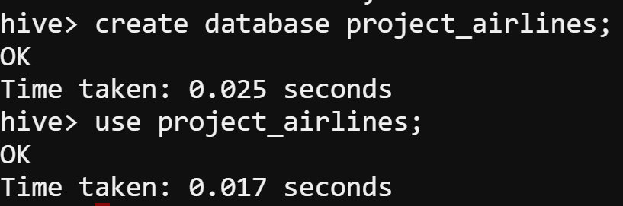

Creating table airports

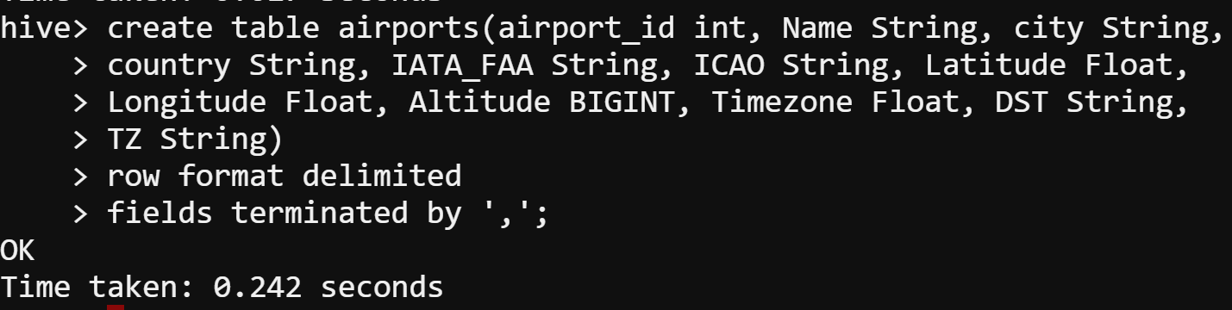

Loading data airports_mod.dat into table airports



A. Find list of Airports operating in the Country India





(I have changed the O/P file name manually. Open the file in Notepad++)

Creating table routes

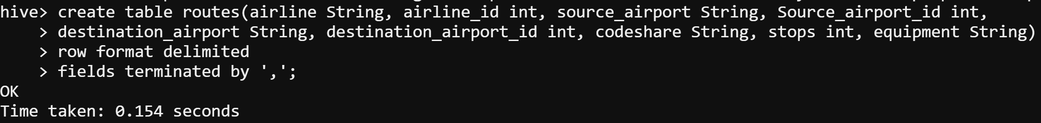

Loading data routes.dat into table routes



Creating table airlines

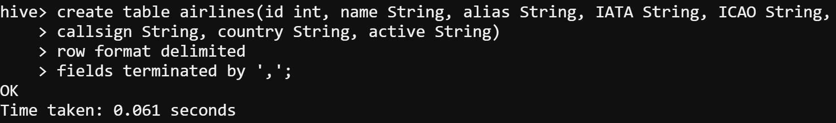

Loading data airlines into table airlines



B. Find the list of Airlines having zero stops





(I have changed the O/P file name manually. Open the file in Notepad++)

C. List of Airlines operating with code share





(I have changed the O/P file name manually. Open the file in Notepad++)

D. Which country (or) territory having highest Airports





(I have changed the O/P file name manually. Open the file in Notepad++)

1. E. Find the list of Active Airlines in United state





(I have changed the O/P file name manually. Open the file in Notepad++)